NATIONAL INSTITUTE OF TECHNOLOGY, DURGAPUR

SOFTWARE ENGINEERING LABORATORY

ASSIGNMENT 5

SEQUENCE DIAGRAMS

Name – Shubhabrata Ghosh

Roll – 20CS8003

Regn. – 20U10008

Sec – X Sub- CSS751

Dept- CSE(2020-2024)

Question 1:  
1. Design a Sequence Diagram for a Smart Home Automation System using IoT devices. The system allows users to control various smart devices within their home remotely using a mobile application.

a. Identify the main components involved in the Smart Home Application and their relevant functions.

b. Determine the interactions and communication between these components during a typical home automation session.

c. Define the sequence of messages exchanged between components, indicating the type of messages (synchronous, asynchronous, etc.).

d. Include conditions or loops if applicable to showcase different scenarios during the automation process.

e. Provide a brief description of each component and its role in the system.

Solution:

Description:

Mobile App: This acts as the interface which the user can use to operate home appliances through the internet, provided the master controller node is online.

Master Controller: This is the main IoT node that controls all the smart appliances and remains online and connected to the appliances via home network.

Lights: These can be toggled on/off by the master controller. Specific lights such as balcony or corridor lights can be programmed to be automatically turn on and off at a specific time, upon signal by master node.

Geysers: User can control water temperature without going inside bathroom. It can turn on automatically upon receiving signal from master node in case the user forgets to switch it on, thus reducing the time utilised to warm up the water.

Refrigerators: Users may leave the door slightly open by mistake. This can be alerted to the mater controller which in turn would alert the user.

AC and Fan: The room temperature from AC and fan RPM can be controlled from the mobile app through the master controller.

Sequence Diagram:

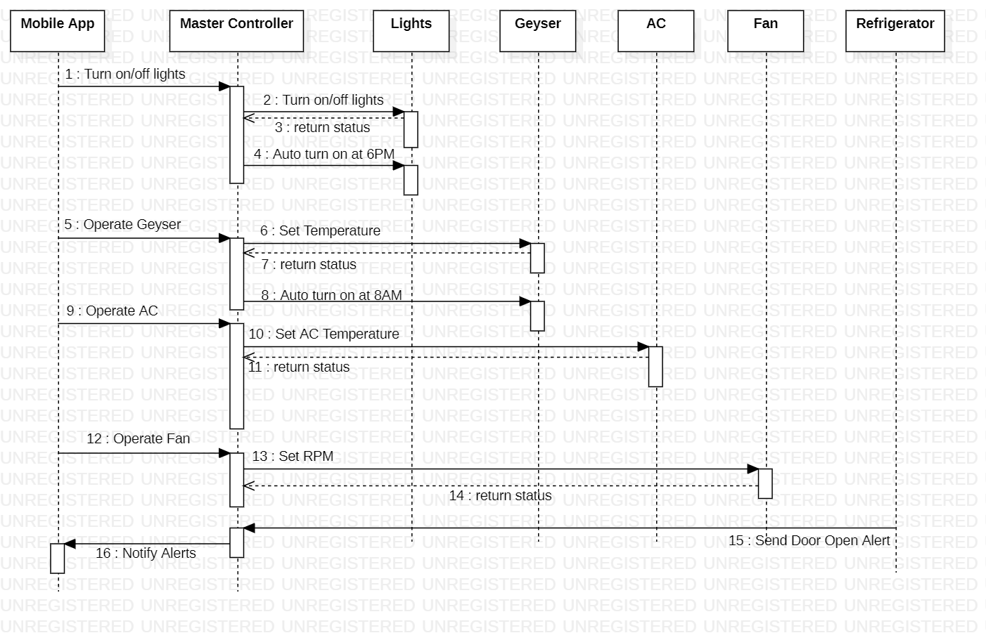

Question 2:

Design a Sequence Diagram for an Anomaly Detection System. The system is responsible for detecting anomalies in a streaming data environment, such as network traffic, and triggering alerts when unusual patterns are identified.

a. The system processes incoming data streams in real-time.

b. Anomaly detection algorithms are applied to the incoming data to identify abnormal patterns.

c. When an anomaly is detected, an alert is generated and sent for further action

Solution:

Sequence Diagram: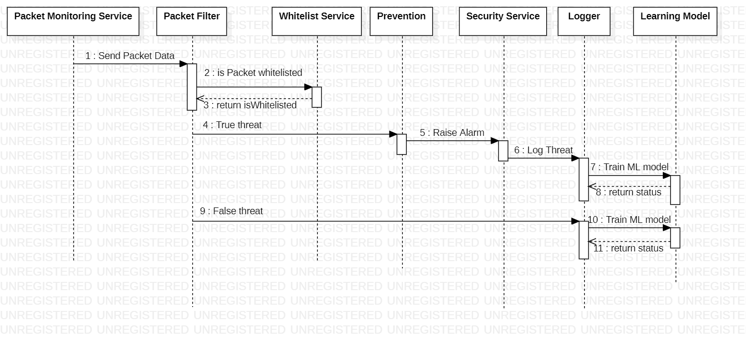

Question 3:  
Design a Sequence Diagram for a Movie Recommendation System that provides personalized movie recommendations to users based on their preferences and viewing history.

a. The system takes input from the user regarding their movie preferences, genres, and past viewing history.

b. The system processes this information to generate personalized movie recommendations. c. The system presents these recommendations to the user.

Solution:

Sequence Diagram:  
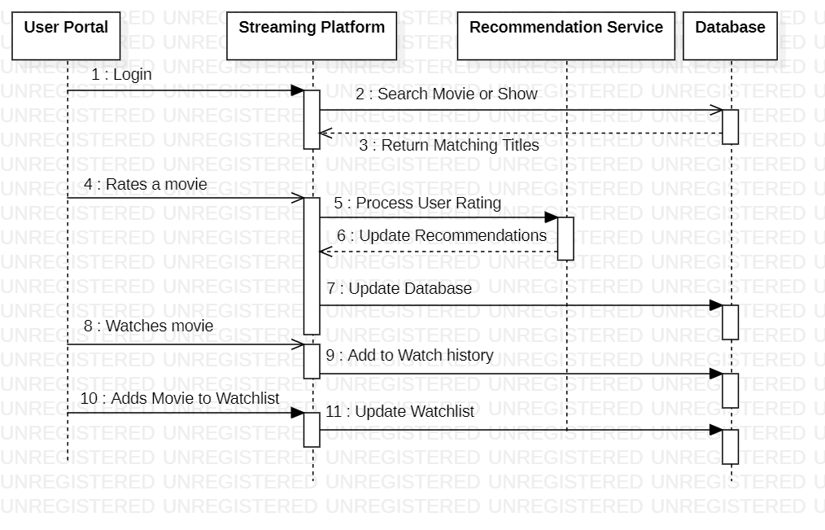

Question 4:  
Develop a sequence diagram for an online auction system. Include interactions between bidders, the auction server, and the bidding database. Highlight steps such as item listing, bidding, bid validation, and auction closure.

Solution:  
Sequence Diagram:  
